General Safety Information

WARNING
• Use neutral detergent to clean the chain. Do not use alkali-based or acid based detergent such as rust cleaners as it may result in damage and/or failure of the chain.
• Use the reinforced connecting pin only for connecting the narrow type of chain.
• There are two different types of reinforced connecting pins available. Be sure to check the table below before selecting which pin to use. If connecting pins other
Technical Service Instructions SI-5VV0B

RD-M751/RD-M571/
Rear derailleur
RD-M511

Chain length on bicycles with rear suspension
The length of A will vary depending on the movement of the rear suspension. Because of this, an excessive load may be placed on the drive system if the chain
length is too short. Set the length of the chain by adding two links to the chain when the rear suspension is at a position where dimension "A" is longest and the chain is on the largest sprocket and the largest chainring. If the amount of movement of the
rear suspension is large, the slack in the chain may not be taken up properly when the chain is on the smallest chainring and smallest sprocket.
3. Low adjustment
Turn the low adjustment screw so that the guide pulley moves to a position directly in line with the largest sprocket.

Largest sprocket
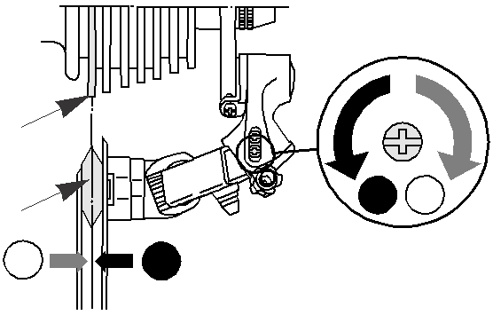

1 2
Guide pulley

than reinforced connecting pins are used, or if a reinforced connecting pin or tool which is not suitable for the type of chain is used, sufficient connection force may not be obtained, which could cause the chain to break or fall off.
In order to realize the best performance, we recommend that the following combination be used.

Largest
Chain

Largest
Low adjustment
2 screw

Chain

9-speed super narrow chain such as
CN-7701 / CN-HG93
8- / 7- / 6-speed narrow chain such as
CN-HG50 / CN-IG51

Reinforced connecting pin

Silver
6.5mm

Black
7.1mm

Chain tool

TL-CN32 / TL-CN23

TL-CN32 / TL-CN23

A'
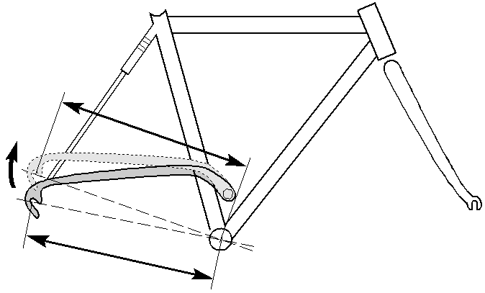

Add 2 links (with the chain on both the largest sprocket and
A the largest chainring)

4. How to use the B-tension adjustment screw
Mount the chain on the smallest chainring and the largest sprocket, and turn the crank arm backward. Then turn the
B-tension adjustment screw to adjust the guide pulley as close to the sprocket as possible but not so close that it touches. Next,
set the chain to the smallest sprocket and repeat the above to

• If it is necessary to adjust the length of the chain due to a change in the number of sprocket teeth, make the cut at some other place than the place where the chain has been joined using a reinforced connecting pin or an end pin. The chain will be damaged if it is cut at a place where it has been
joined with a reinforced connecting pin or an end pin.

Reinforced Connecting Pin

End Pin Link Pin

Specifications
Rapidfire M9 (Shifting lever) | SL-M751 | SL-M571 | SL-M511
Outer casing | SIS-SP41
Rear derailleur | RD-M751 | RD-M571 | RD-M511
Type | SGS / GS |  | SGS
Freehub | FH-M765 / FH-M760 | FH-M585 / FH-M580 | FH-M530 / FH-M535
Gears | 9
Chain | CN-HG93 | CN-HG73 | CN-HG53
Bottom bracket guide | SM-SP17 / SM-BT17

Adjustment

Largest sprocket Smallest sprocket
2
2

1 2
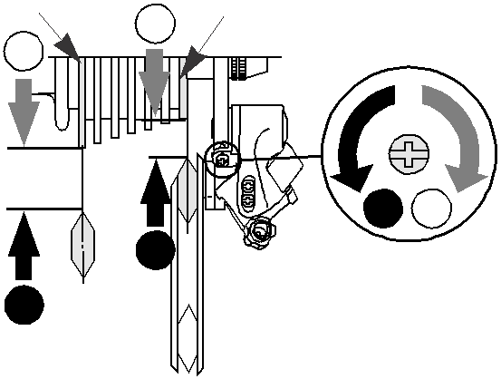

• Check that the tension of the chain is correct and that the chain is not damaged. If
the tension is too weak or the chain is damaged, the chain should be replaced. If this is not done, the chain may break and cause serious injury.
• Obtain and read the service instructions carefully prior to installing the parts. Loose, worn, or damaged parts may cause injury to the rider. We strongly recommend only using genuine Shimano replacement parts.
• Read these Technical Service Instructions carefully, and keep them in a safe place for later reference.

Rear Derailleur
Model number | RD-M751 / RD-M571 / RD-M511 | RD-M751 / RD-M571
Type | SGS | GS
Gears | 9 | 9
Total capacity | 45T | 33T
Largest sprocket | 34T | 34T
Smallest sprocket | 11T | 11T
Front chainwheel tooth difference | 22T | 22T

1. Top adjustment
Turn the top adjustment screw to adjust so that the guide pulley is in line with the outer line of the smallest sprocket when looking from the rear.

1 2

Guide pulley

Outer line of smallest sprocket

1 2
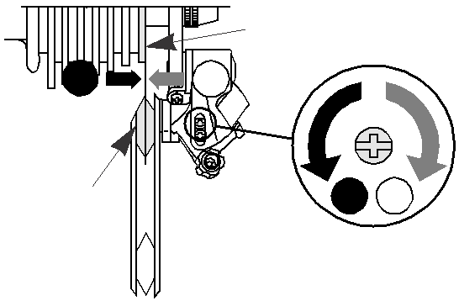

Top adjustment
1
1

5. SIS Adjustment

B-tension adjustment screw

Note
• If gear shifting operations do not feel smooth, wash the derailleur and lubricate all
moving parts.
• If the amount of looseness in the links is so great that adjustment is not possible,
screw
Operate the shifting lever several times to move the chain to the
2nd sprocket. Then, while pressing the lever just enough to take up the play in the lever, turn the crank arm.

you should replace the derailleur.
• You should periodically clean the derailleur and lubricate all moving parts
(mechanism and pulleys).
• If gear shifting adjustment cannot be carried out, check the degree of parallelism at the rear end of the bicycle. Also check if the cable is lubricated and if the outer casing is too long or too short.
• If you hear abnormal noise as a result of looseness in a pulley, you should replace the pulley.
• If the chain keeps coming off the sprockets during use, replace the sprockets and the chain.
• Use a frame with internal cable routing is strongly discouraged as it has tendencies to impair the SIS shifting function due to its high cable resistance.

These Service Instructions describe the operation method when using the Rapidfire SL-M751/M571/M511 in combination with the RD-M751/M571/M511 top normal-type rear derailleur. If using in combination with the RD-M760/ M580/M530 reverse spring-type derailleur, the operations and indicator displays will be reversed.

Gear shifting operation

Both lever (A) and lever (B) always return to the initial position when they are released after shifting. When operating one of

2. Connection and securing of the inner cable Operate lever (B) 8 or more times to set the lever to the highest position, check on the indicator that the highest position is correct, and then install and
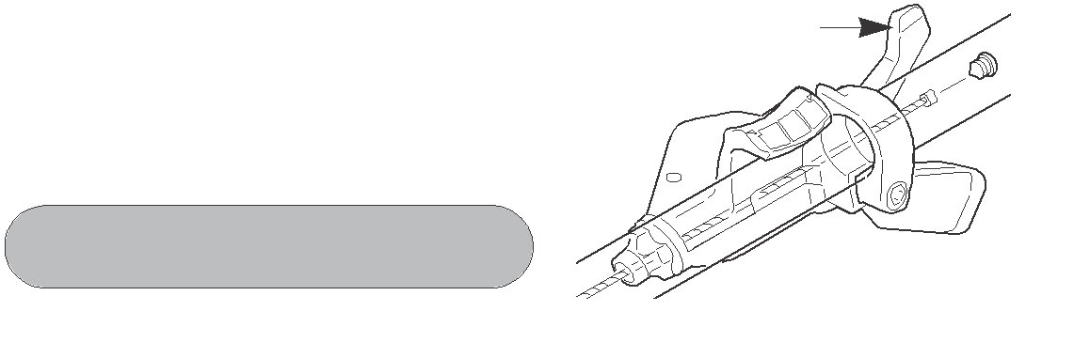

adjust the inner cable.

Tightening torque :
5 - 7 N·m {44 - 60 in. lbs.}

Lever (B)
When shifting to
3rd

Outer casing adjustment barrel
When no sound
at all is heard

Outer casing adjustment barrel

• Always be sure to use the sprocket set bearing the same
group marks. Never use in combination with a sprocket bearing a different group mark.
• Use an outer casing which still has some length to spare even when the handlebars are turned all the way to both sides. Furthermore, check that the shifting lever does not touch the bicycle frame when the handlebars are turned all the way.
• Make sure that the gear shifting cable and the brake cable do not obstruct each other during braking operations. If they do
Group marks
the levers, always be sure to turn the crank arm at the same time.

To shift from a small sprocket to a larger sprocket (Lever A)
To shift one step only, press lever (A) to the (1) position. To shift two steps at one time, press to the (2) position.
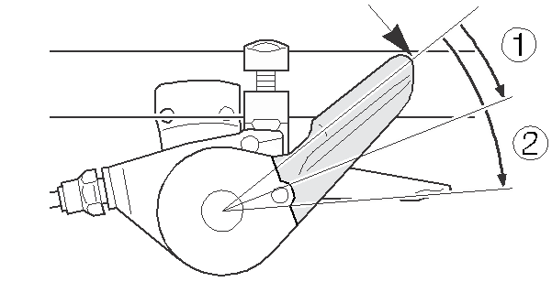

Lever (A) initial position

To shift from a large sprocket to a smaller sprocket (Lever B)
Press lever (B) once to shift one step from a larger to a smaller sprocket.

Install the inner hole cover by turning it as shown in the illustration until it stops.
Do not turn it any further than this, otherwise it may damage the screw thread. In addition, if the unit cover becomes bent, it may cause the unit cover to get in the way of the feed lever
and prevent the feed lever from operating correctly.

Feed lever
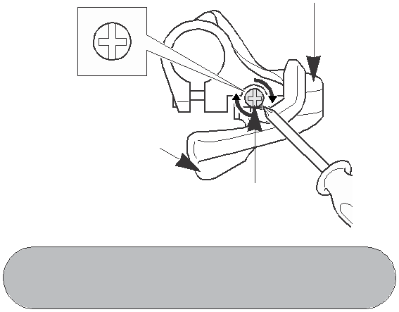

Unit cover
Tighten the outer casing adjustment barrel until the chain returns to the 2nd sprocket. (clockwise)

Best setting

Loosen the outer casing adjustment barrel until the chain touches the 3rd sprocket and makes noise. (counter clockwise)

obstruct, it may interfere with braking.
Install the cables so that they still have some slack in them even when the handlebars are turned fully in either direction.
• A special grease is used for the gear shifting cable (SIS-SP41). Do not use DURA- ACE grease or other types of grease, otherwise they may cause deterioration in gear shifting performance.
• Grease the inner cable and the inside of the outer casing before use to ensure that they slide properly.
• For smooth operation, use the specified outer casing and the bottom bracket cable guide.

Lever (B)
If the feed lever does not return correctly, loosen the inner hole cover slightly, and then move the feed lever and the unit cover apart and check if this improves the returning of the feed lever.

Cutting the outer casing
Inner hole cover

Tightening torque :
0.3 - 0.5 N·m {3 - 4 in. lbs.}
The best setting is when the shifting lever is operated just enough to take up the play and the chain touches the 3rd sprocket and makes noise.
* Return the lever to its original position (the position where the lever is at the 2nd sprocket setting and it has been released) and then turn the crank arm clockwise. If the
chain is touching the 3rd sprocket and making noise, turn the outer casing adjustment barrel clockwise slightly to tighten it until the noise stops and the chain runs smoothly.

• Operation of the levers related to gear shifting should be made only when the front chainwheel is turning.
• Parts are not guaranteed against natural wear or deterioration resulting from normal use.
• For maximum performance we highly recommend Shimano lubricants and maintenance products
• For any questions regarding methods of installation, adjustment, maintenance or operation, please contact a professional bicycle dealer.

Installation of the lever

Use a handlebar grip with a maximum outer diameter of 32 mm.

• Install the shifting lever in a position where it will not obstruct brake operation and gear shifting operation.
• Do not use in a combination which causes brake operation to be obstructed.
• In the case of carbon handlebars, it may be necessary to lower the tightening torque in order to prevent damage to the
handlebar. Please consult the bicycle or handlebar manufacturer

5 mm Allen key

Tightening torque :
5 N·m {44 in. lbs.}
When cutting the outer casing, cut the opposite end to
the end with the marking. After cutting the outer casing, make the end round so that the inside of the hole has a uniform diameter.

Outer end cap
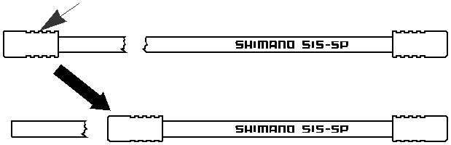

Attach the same outer end cap to the cut
end of the outer casing.
Operate lever to change gears, and check that no noise occurs
in any of the gear positions.

For the best SIS performance, periodically lubricate all power-transmission parts.

regarding the appropriate level of tightening torque for carbon handlebars.

Installation of the rear derailleur
When installing, be careful that deformation is not caused by the B-tension adjustment screw coming into contact with the dropout tab.

Bracket spindle Tightening torque :
8 - 10 Nm {70 - 86 in. lbs.}

5 mm Allen key
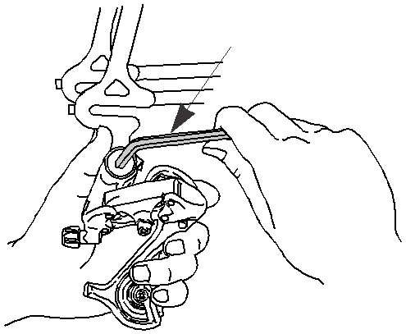

Dropout tab

B-tension adjustment screw
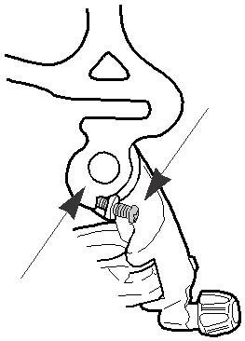

Connect the cable to the rear derailleur and, after taking up the initial slack in the cable,
re-secure to the front derailleur as shown in the illustration.

Pull
Note: Be sure that the cable is securely in the groove.

Groove
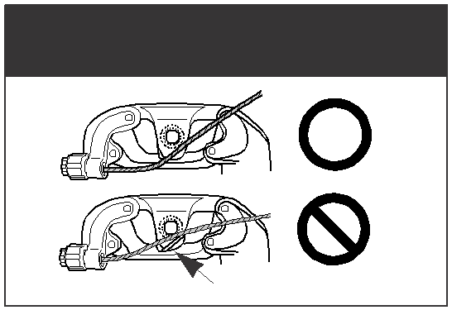

This service instruction explains how to use and maintain the
Shimano bicycle parts which have been used on your new bicycle.
For any questions regarding your bicycle or other matters which
are not related to Shimano parts, please contact the place of purchase or the bicycle manufacturer.

One Holland, Irvine, California 92618, U.S.A. Phone: +1-949-951-5003

Industrieweg 24, 8071 CT Nunspeet, The Netherlands Phone: +31-341-272222

3-77 Oimatsu-cho Sakai-ku, Sakai, Osaka 590-8577, Japan
Please note: specifications are subject to change for improvement without notice. (English)
© Jun. 2006 by Shimano Inc. XBC SZK Printed in Singapore.

